**DIGITAL MARKETING**

**ASSIGNMENT-1**

**Create a blog or website using Blogspot and Wordpress. Customize the theme design and post new article with 500 words.**

|  |  |
| --- | --- |
| **NAME** | Angelin Gracia A |
| **REG NO** | 962220106013 |
| **NM ID** | 7CD89466BFE0F9995924F8E1702A87CA |
| **TEAM ID** | NM2023TMID08872 |

BLOGSPOT:

<https://duckanime4you.blogspot.com/2023/08/straw-hat-crew.html>

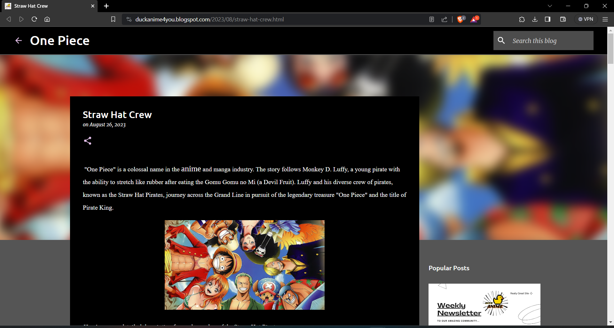

WORDPRESS: <https://duckanime.wordpress.com/one-piece-crew>

